
SIMATS ENGINEERING
Department of Computer Science and Engineering

CSA15 Cloud Computing and Big Data Analytics

CO3 AT2 - Capstone Cloud Access and Service Integration Case Study Student Template

Course Code | CSA15 | Course Title | Cloud Computing and Big Data Analytics
Assessment | CO3 AT2 - Capstone Cloud Access and Service Integration Case Study | Submission Type | Individual digital case-study document
Faculty | Dr C. Rajesh Babu | Employee ID | SSETSCS415
Mode | Case study / capstone design reasoning | Submission | GitHub repository link through Google Classroom
How This Template Works
Read each case, connect it to the technical ideas learned in CO3 AT1, and then extend the design to
your own capstone product. The answer must show cloud access, APIs, storage, serverless/event flow and edge/fog/cloud reasoning. Do not upload passwords, private keys, API tokens or sensitive personal data.

Student and Capstone Details

Student Name | M Deepika
Register Number | 192311027
Class / Slot | Slot B
Capstone Title | Cloud-Based Medicine Inventory Management System
CO3 AT1  Evidence Link | https://classroom.google.com/u/0/c/ODcwMzQ3MDExMjg1/a/ODcxNTQ1NTg5MDc0/details
GitHub Repository Link | https://github.com/mdeepika2006/CCBD1512-Cloud-Computing-Assessment
Submission Date

Case 1: Cloud-Native Backend and Web API Architecture
Scenario

A food delivery company wants to deploy a cloud-native backend with web APIs, browser/mobile clients and shared cloud storage for receipts and delivery images. Design the architecture and explain the role of each component.

Case Architecture Diagram
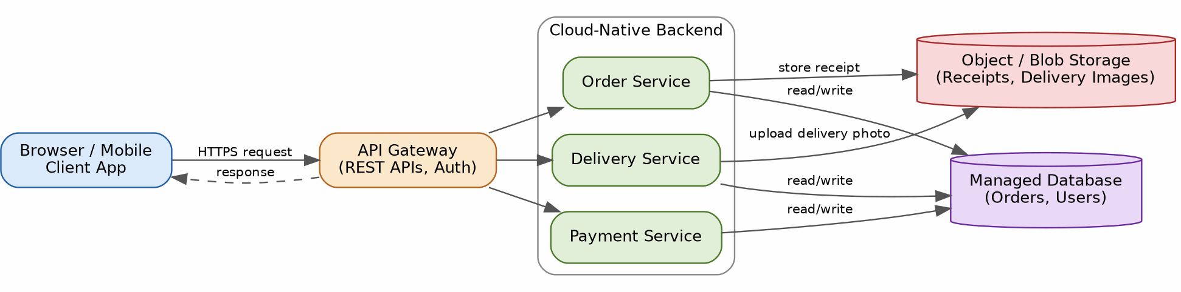

The architecture uses a cloud-native backend exposed through a single API Gateway. Browser and mobile clients never talk to services directly; every request is authenticated and routed at the gateway, which keeps the client thin and the backend independently scalable.
Order, Delivery and Payment are separate microservices so each can be deployed, scaled and updated on its own. Structured data (orders, users, delivery status) lives in a managed database, while receipts and delivery-proof images are written to object/blob storage instead of the database, since large binary files are cheaper and faster to serve from object storage.

Component Role Explanation
- Browser/Mobile Client – presentation layer; captures user actions (place order, upload delivery photo) and renders responses. Holds no business logic or credentials.
- API Gateway – single entry point; terminates HTTPS, authenticates the caller (JWT/OAuth token), applies rate limiting, and routes each request to the correct backend service.
- Order / Delivery / Payment Services – independently deployable microservices, each owning its slice of business logic so a spike in one (e.g., Payment during a sale) does not affect the others.
- Managed Database – stores structured, relational data (orders, customers, delivery status) that needs transactions and consistency.
- Object/Blob Storage – stores unstructured binary data (receipt PDFs, delivery-confirmation photos) with a URL/key returned to the database record, keeping the database small and fast.

Capstone Extension: user-to-cloud workflow for your product
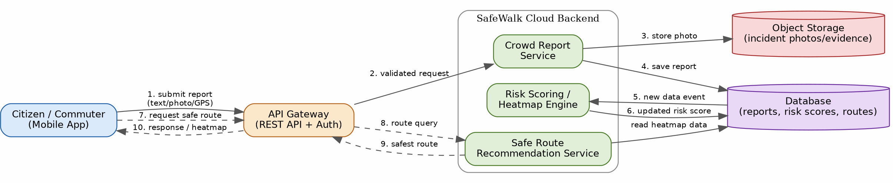

For SafeWalk, the same pattern is reused. A citizen submits a crowd report (text, photo, GPS location) from the mobile app. The API Gateway authenticates the request and forwards it to the Crowd Report Service, which stores the photo in object storage and the report metadata in the database.

A new report is an event that the Risk Scoring / Heatmap Engine reacts to, recalculating the risk score for that zone. The Route Recommendation Service reads the latest risk scores to suggest the safest path when a user later requests directions, and the updated heatmap is returned to the client through the same API Gateway.

Case 2: Storage and Serverless Upload Workflow

Scenario
A media startup must decide between SAN-backed storage, object storage and serverless processing for upload workflows. Recommend a deployment model and justify it.
Data / Event | Best Storage | Serverless Action | Reason
Incident report photo/video | Object storage (e.g., S3-class bucket) | Trigger on upload: validate file, run moderation check, extract EXIF/GPS metadata | Large binary files are costly and slow to store in a relational DB; object storage scales automatically and serves media directly via URL.
Text/GPS crowd report | NoSQL/managed database (reports table) | Trigger on insert: recompute the risk score for that geo-zone | Reports are semi-structured, high-write, and queried by location/time  — a document/NoSQL store handles this pattern with low latency.
Aggregated zone risk score | In-memory cache / fast key-value store | Trigger on score update: refresh the public heatmap tile and push alerts to nearby users | The heatmap is read far more often than it is written, so caching avoids recomputing it on every route request.
Historical reports (>90 days) | Cold/archive object storage tier | Scheduled (time-based) trigger: move old records from hot storage to archive tier | Old data is rarely accessed but must be retained for analytics/audit, so a cheaper archive tier reduces cost without deleting evidence.

Storage and Serverless Recommendation
SafeWalk should use object storage (not SAN-backed block storage) for all crowd-submitted media, combined with a serverless processing layer, for three reasons:
- Elastic, unpredictable load – incident reports spike sharply during events (accidents, protests, bad weather); object storage plus serverless functions scale to zero when idle and scale out instantly during a spike, whereas SAN-backed storage needs pre-provisioned capacity.
- Event-driven processing fits the workflow naturally – every upload is a discrete event (validate, moderate, extract GPS, update risk score); serverless functions are billed per invocation, which is

far cheaper than running an always-on server to handle occasional uploads.
3. Durability and cost – object storage offers built-in replication/versioning at a much lower cost per GB than SAN storage, which matters because SafeWalk retains photo evidence for audit and dispute resolution.
SAN-backed storage is reserved only for the low-latency database volumes that back the live risk-score lookups, where consistent block-level I/O performance matters more than elasticity.

Failure Handling and Cost/Performance Explanation
Failure handling: every upload event is placed on a queue/event bus before the serverless function processes it. If the moderation or metadata-extraction function fails or times out, the event is automatically retried a fixed number of times and then moved to a dead-letter queue so no report is silently lost; an alert notifies the on-call engineer to reprocess it manually.
Idempotency: each function is written to be safely re-run (using the report ID as an idempotency key) so a retry cannot create duplicate reports or double-count a risk score.
Cost/performance trade-off: serverless functions cost more per unit of compute time than a dedicated server, but because SafeWalk's upload traffic is bursty and unpredictable, paying only per invocation is cheaper overall than keeping a server running 24/7 for occasional spikes. The heatmap cache absorbs the high read volume so the database is not hit on every route lookup, keeping both cost and response latency low.

Capstone Extension: one upload/event workflow

Walkthrough: (1) the mobile app uploads a photo and report metadata directly to an object storage bucket; (2) the upload automatically fires a storage event; (3) a serverless function validates and moderates the image, then writes a report record to the database; (4) the new record triggers a second function that recomputes the risk score for that zone; (5) the updated score refreshes the heatmap cache and (6) triggers a push notification so nearby users are alerted in near real time — all without a server that has to be provisioned or kept running.

Case 3: Edge, Fog and Cloud Placement

Scenario
A smart-city platform needs low-latency decision-making near sensors while still using the cloud for analytics. Decide what runs at edge, fog and cloud.
Task | Layer | Latency Need | Data Volume | Reason
Detect device motion / capture GPS for a new report | Edge (on user's phone) | Very low (instant) | Very small (single event) | Must work even with poor connectivity; no round trip to the cloud is acceptable for local UX feedback.

Aggregate reports into a zone-level heatmap update | Fog (regional edge node) | Low (seconds) | Medium (many nearby reports) | Needs to combine multiple nearby reports quickly for a local alert, but doesn't need global context, so a nearby fog node is faster and cheaper than a round trip to the central cloud.
Push an immediate 'unsafe area' alert to nearby users | Fog | Low (near real time) | Small (targeted alert) | Latency-critical safety alerts must reach users within a small geo-radius fast; routing through the central cloud would add unnecessary delay.
Train/update the citywide risk-prediction ML model | Cloud | High (batch, minutes–hours acceptable) | Large (historical, citywide data) | Model training needs the full historical dataset across all zones and heavy compute, which only the central cloud can provide cost-effectively.

Edge/Fog/Cloud Architecture Explanation

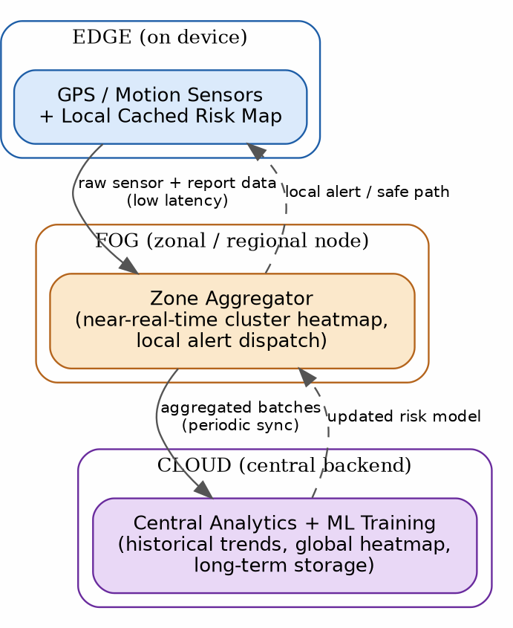

Edge (on the user's device): GPS/motion sensing and a locally cached copy of the current risk map run on the phone so the app can warn a user about a known unsafe street even with no network signal.
Fog (zonal node close to a neighbourhood/campus): a regional aggregator combines crowd reports from many nearby devices into a near-real-time cluster heatmap and dispatches local safety alerts
— this keeps latency low because the data never has to travel to a distant central data centre for a time-critical alert.
Cloud (central backend): performs the heavy, non-urgent work — long-term storage of all historical reports, training/refining the machine-learning risk-prediction model, and producing citywide analytics dashboards — then periodically pushes an updated risk model back down to the fog layer.

Capstone Extension or Direct Cloud Access Justification
Not every request in SafeWalk needs edge or fog processing. When a user opens the app to view the citywide heatmap, browse historical safety trends for a neighbourhood, or search a route far outside their current zone, the app connects directly to the cloud API, because:
- That data (long-term history, citywide aggregation) only exists centrally — there is nothing for an edge/fog layer to add.
- The request is not latency-critical in the same way as a live safety alert; a second or two of extra round-trip time is acceptable for a dashboard view.
- Skipping unnecessary fog hops for non-urgent requests keeps the fog nodes' limited compute capacity free for what they exist to do — real-time, hyper-local alerting.

Final Capstone Cloud Access Architecture
Show Browser/Mobile Client.
Show hosted frontend or app access path.
Show REST API endpoint and authentication check. Show backend/serverless logic.
Show database, object/blob storage, logs and monitoring.
Label the arrows: request, response, upload, event, notification or monitoring signal.

Final Diagram and Explanation
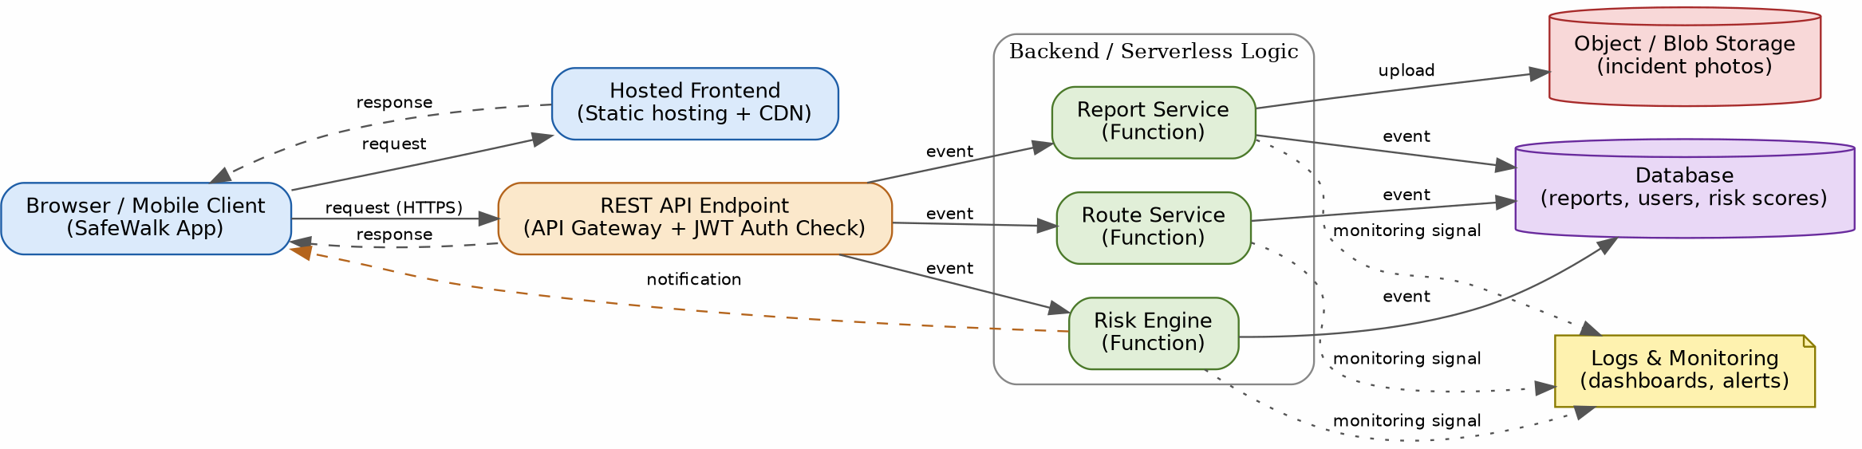

End-to-end flow: the Browser/Mobile Client loads the SafeWalk app from a hosted, CDN-served frontend (request/response). All data operations go through a single REST API Endpoint, where the API Gateway checks a JWT auth token before allowing the call through (request (HTTPS) / response).
Authenticated requests become events handled by three backend functions: the Report Service (uploads incident photos to object/blob storage and writes a record to the database), the Risk Engine (recalculates zone risk scores and can send a push notification), and the Route Service (reads risk scores from the database to recommend a safe path).
Every function emits a monitoring signal to a central Logs & Monitoring layer, giving visibility into errors, latency and usage without exposing that data to end users. This design satisfies all required elements: client, hosted frontend, authenticated REST API, serverless backend logic, database and blob storage, and logging/monitoring, with every arrow labelled by its purpose.

Submission Checklist
Template completed in DOCX format.

Diagrams pasted clearly in the document.
GitHub repository contains DOCX/PDF, diagrams and README. Google Classroom submission contains GitHub link.
Sensitive credentials are not visible anywhere.

Student Assurance
Declaration
I confirm that this case-study answer, cloud access design, diagrams and capstone extensions were prepared individually by me for the stated capstone title.

Student Signature: M Deepika Date:

